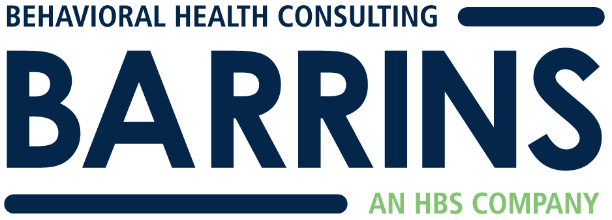
Sample Resource

The following is a sample Infection Prevention and Control Plan for Behavioral Health settings. The plan must be customized to your setting. Each section contains instructions on the TJC requirements and the relevant standard number in the Behavioral Health Standards Manual. Please reference that standard to understand the full TJC requirements.

INFECTION PREVENTION AND CONTROL PLAN

Purpose of the Infection Prevention and Control Program

The purpose of the Infection Prevention and Control Program at XYZ Behavioral Health is to identify and reduce the risks of acquiring and transmitting infections among clients, staff and visitors at all locations of XYZ Behavioral Health Program.

Authority and Responsibility for the IC Program
(See IC.01.01.01 EP 3)

Describe who has been assigned responsibility for the organization-wide IC program and the committee/forum in which IC information and planning will take place.

At XYZ Behavioral Health, an individual has been identified by leadership to manage infection prevention and control activities. That individual is the Health and Safety Coordinator. The Health and Safety Coordinator has the following responsibilities related to the Infection Prevention and Control Program:
- Develop policies and procedures related to infection surveillance, prevention, and control activities
- Promote the implementation of organizational policies related to infection prevention and control
- Develop and implement a process for surveillance and control of infections
- Conduct an annual review of the Infection Prevention and Control Program

The Health and Safety Coordinator works with the XYZ Behavioral Health leadership team and the program/site directors to implement the Infection Prevention and Control Program. Infection prevention and control activities and related data are reported quarterly to the Performance Improvement Committee. Each quarter, the agenda of the PI Committee includes a review of infection prevention and control activities for that quarter.

Organization-wide Goals of the Infection Prevention and Control Program
(See IC.01.04.01 EP 1-5)

The organization-wide goals of the Infection Prevention and Control Program are as follows:
- To address the priority infection risks for our client population
- To limit unprotected exposure to germs
- To limit the spread of infections associated with the use of medical supplies (such as needles and syringes) and medical devices (such as glucometers) at any locations that use such medical supplies and devices
- To improve staff compliance with hand hygiene guidelines

Infection Control Risk Assessment and Priority Risks
(See IC.01.03.01 EP 1-3)

Describe your geographic setting, population served, and services provided. Based on
those features, identify specific risks for your client population.

The identification of specific risks for XYZ Behavioral Health is based on the characteristics of the population served by our organization and our setting. XYZ Behavioral Health provides community based services to adults with serious and persistent mental illness in an urban setting in southeastern Massachusetts. These services include intensive case management, medication management, and vocational services. There are no residential services provided. Since all of the services are non-24 hour care, the focus of the Infection Prevention and control Program will be on education of staff and clients regarding infection risks and how to minimize these risks and prevent the spread of infections. Based on these features, the following priorities for infection control risks have been identified among our client population:
- Influenza
- Upper respiratory infections
- Inadequate hand hygiene

Goals Related to Priority Infection Control Risks
(See IC.01.04.01 EP 1)

Based on the prioritized risks that have been identified, the following goals have been established for the Infection Prevention and Control Program.

Goal # 1 related to the prioritized risk of influenza:
To improve staff participation in the influenza vaccination program. For 2015-2016: Increase staff compliance with influenza vaccination to 75% (from 58% in 2014-2015)

Implementation Strategies:
- Offer influenza vaccination to all employees free of charge
- Arrange for on-site influenza vaccinations at all locations
- Educate staff about the influenza vaccine, non-vaccine control and prevention measures and the diagnosis, transmission, and impact of influenza
- Educate staff on appropriate hand hygiene measures
- Monitor state and national data regarding influenza trends to inform planning

Goal # 2 related to the prioritized risk of upper respiratory infections:
To decrease the spread of upper respiratory infections among staff and clients in the workplace

Implementation Strategies:
- Educate staff about appropriate hand hygiene including hand washing and the use of alcohol based hand sanitizers
- Educate staff on appropriate cough etiquette
- Post hand hygiene educational materials in staff and client rest rooms at all locations
- Provide wall mounted hand hygiene dispensers at locations that provide hands-on medical care
- Implement hand hygiene procedures for staff and clients at locations that serve food
- Provide facial tissues for staff and clients at convenient locations throughout the organization
- Provide portable hand sanitizer containers for staff working with clients in the community

Goal # 3 related to the prioritized risk of inadequate hand hygiene: To improve staff knowledge of appropriate hand hygiene (See IC.01.04.01 EP 5)

Implementation Strategies:
- Educate staff about appropriate hand hygiene at initial employee orientation
- Provide annual update training on hand hygiene to all staff
- Orient clients to appropriate hand hygiene as part of their orientation
- Post hand hygiene educational materials in staff and client rest rooms at all locations
- Provide wall mounted hand hygiene dispensers at locations that provide hands-on medical care
- Implement hand hygiene procedures for staff and clients at locations that serve food
- Provide portable hand sanitizer containers for staff working with clients in the community
- Evaluate staff knowledge about proper hand hygiene via quizzes at orientation and annual training
- For locations that provide hands-on care, a process for conducting observations of hand hygiene will be established. Data will be collected regarding compliance with hand hygiene procedures. This data will be aggregated and target goals will be set based on the baseline data collected.

Surveillance and Data Collection
(See IC.01.05.01 EP 2)

Describe how you will monitor infection risks and how you will collect data on client infections.

Surveillance of infections and infection control risks will be conducted through the following methods:

- Reporting of client infections via the Incident Reporting process
  - When a staff member becomes aware of a client that has an infection or suspected infection, the staff member will offer information to the client about obtaining treatment for the infection/suspected infection. The staff member will also report the infection on an Incident Report Form.
  - Staff who experience an infection and wish to voluntarily report the infection may do so by completing an Illness and Injury Report form. When staff have or are suspected of having an infectious disease that puts others at risk, they will be referred for assessment and treatment.
  - Data regarding the number and types of infections will be reported quarterly at the PI Committee. The data will be analyzed to determine if there are ways to improve the Infection Prevention and control Program.

- Periodic infection control rounds completed by the Health and Safety Coordinator
  - On a quarterly basis, the Health and Safety Coordinator will complete infection control rounds to monitor compliance with established infection control procedures including hand hygiene practices and the cleanliness of the environment. Results of these rounds will be reported quarterly at the PI Committee.

In addition to these surveillance methods, XYZ Behavioral Health will report infectious diseases to the Department of Public Health as required by state regulations and the Public Health Code.

Response to an Outbreak of Infectious Disease
(See IC.01.05.01 EP 5, IC.01.06.01 EP 4)

Describe how you would handle an infectious outbreak.

If it is determined that there is an outbreak of infectious disease within XYZ Behavioral Health or in the surrounding community, the Health and Safety Coordinator will work with the leadership team to plan and execute a response. The response will be based on guidance from the public health authority and may include the following measures:
- Notifying staff and clients about the potential exposure and actions to take
- Following the specific guidelines issued by the public health authority
- Temporarily limiting admissions
- Temporarily ceasing operations

Handling Infectious Waste
(See IC.02.01.01 EP 6)

Describe how you handle infectious waste such a used sharps or
blood soaked materials if you have those.

Presently, none of the XYZ Behavioral Health programs store or dispose of infectious waste such as used sharps, blood soaked material, or body fluids. In the event that services would be provided that require storage or disposal of these types of materials, arrangements will be made for appropriately storing these materials and disposing of them. In addition, staff will be educated about the proper handling, storage, and disposal of these materials.

Influenza Vaccination Program
(See IC.02.04.01 EP 1-9)

Describe your annual influenza vaccination program.

Each year, at times recommended by the Center for Disease Control, XYZ Behavioral Health will offer an on-site influenza vaccination program for all employees. Employees will be educated about influenza vaccination and non-vaccine control and prevention measures. Any staff who decline the flu vaccine will be required to complete a Declination Form indicating the reason for declining the vaccination. Based on this process, the influenza vaccination rate will be calculated. The methodology for calculating the influenza vaccination rate is as follows:
Denominator: # of employees eligible to take the influenza vaccination
Numerator: # of employees who take the influenza vaccination or have received it from another source.

The data will be aggregated and compiled by the Health and Safety Coordinator and reported to the PI Committee and leadership. Improvement goals will be set annually.

Evaluation of the Infection Prevention and Control Plan
(See IC.03.01.01)

Describe how the IC Plan will be evaluated annually.

XYZ Behavioral Health will evaluate the Infection Prevention and Control Plan annually. The evaluation will include review of the following data:
- Number and types of infections reported during the past year and response to these infections
- Influenza vaccination rate
- Compliance with staff training requirements
- Results of infection control rounds
- Progress toward the goals established in the current year’s plan

This data will be analyzed for patterns and trends and will be used to make modifications to the Infection Prevention and control Program for the coming year.

B&A SAMPLE BH IC Plan May 2015

